Illinois State University
2017 Entry Into Teaching Report

Report Information
The entry in teaching report visualizes full time employment in an Illinois public school.
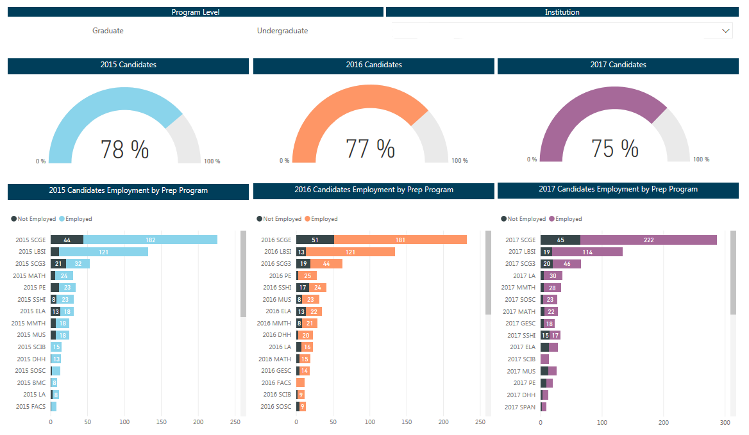
Program Level: Filter the data by selecting undergraduate and/or graduate level.
Completers with Full-Time Employment: View the number of completers from each program year who found full-time employment in teaching or other educational roles within two years of program completion.
Considerations:
- ISBE only collects employment data from the state’s public schools (including charter schools). Completers employed in a non-public or out-of-state school are not included in this report.
- Employment is inclusive of all educational roles requiring a state educator license (excluding substitute teachers). Each year, school districts report all licensed personnel to the State in the Employment Information System (EIS). See Appendix B for a list of all positions requiring educator licensure. Your educators in this report are working in the positions specified in this appendix.

EPP-Wide Data
(N=896)

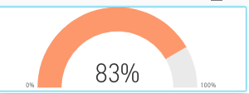

Program-Level Data

