Illinois State University
2017 Student Placement Statewide Report

Report Information
The student placement statewide report visualizes the Institution’s program completers employment location throughout the state of Illinois.
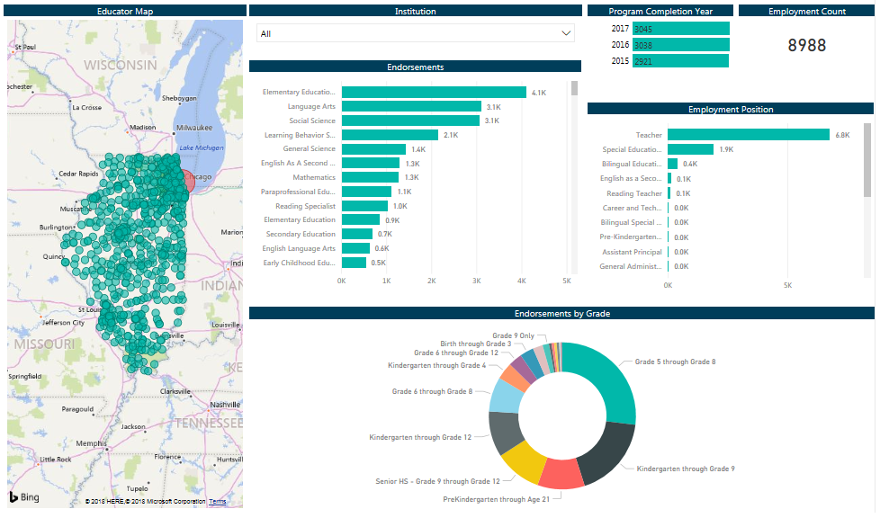
Educator Map: View the districts in which your educators are currently employed. Employment locations are also reflected on the educator heat map. Orange and red circles represent the highest numbers of educators employed in a particular district, while greenish blue circles represent fewer numbers of educators.
Program Completion Year: The number of program completers that are employed in an Illinois public school by program completion year.
Employment Count: Total number of employed completers in an Illinois public school.
Employment Position: The number of employed completers by position in an Illinois public school
Endorsements: The number of employed completers by endorsement in an Illinois public school
Endorsements by Grade: The number of employed completers by grade level in an Illinois public school
Considerations:
- Data listed is for Illinois public schools and charter schools only. Non-public schools are not included.
- Data is inclusive of all of your educator preparation program completers
- Placement data is displayed for the 2017-2018 school year.

EPP-wide Data

