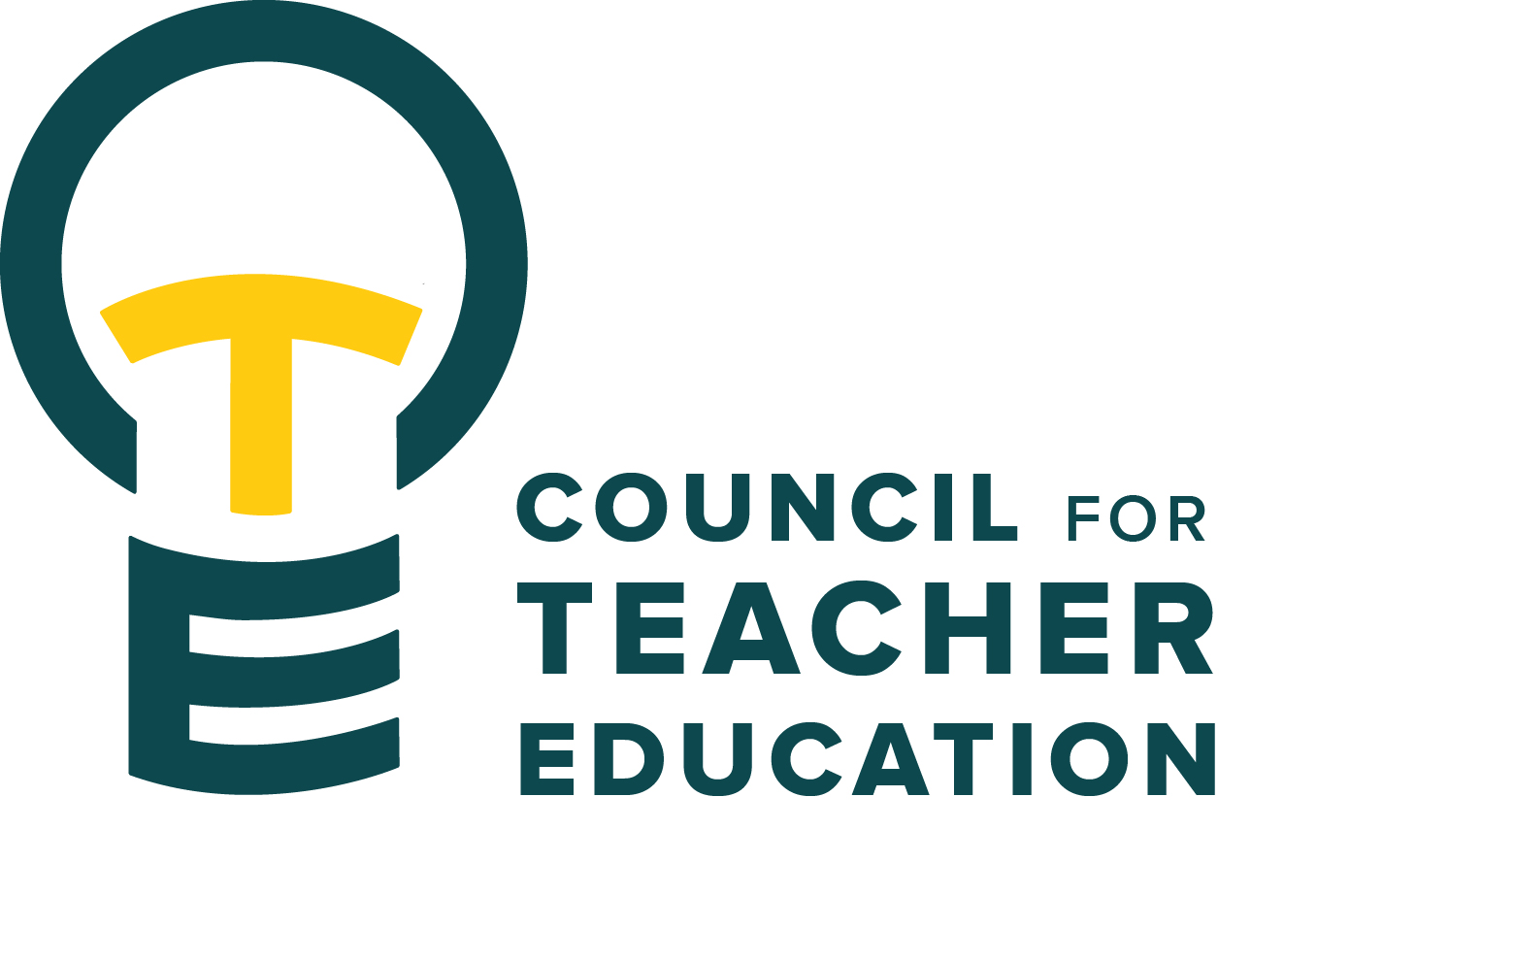

Council for Teacher Education
Meeting Agenda
November 15, 2022, 3:00-4:30 pm, DeGarmo 551
- Call to order
- Roll Call (In Attendance & Absent)
- Approval of minutes from the November 1st meeting
- Information Items:
- CAEP Sub Committee Working Groups – instructions & supported work time
V. Subcommittee Reports:
- Curriculum (Erin Mikulec)
- Student Interests (Jay Percell)
- University Liaison and Faculty Interest (Barb Meyer & Lenford Sutton)
- University Teacher Education Assessment (Christy Bazan & Monica Noraian)
- Vision (Jill Thomas)
VI. Discussion Items:
IX. Action Items:
VIII. Legislative Updates:
IX. Announcements and Last Comments:
X. Adjournment:
Next CTE Executive Board Meeting: December 13, 2022, 2-3 pm Next CTE Subcommittee Meetings: December 13, 2022, 3:00-4:30 pm
Curriculum: Chair Erin Mikulec (DEG 304 3:30-4:30)
Student Interests Committee: Chair Jay Percell (STV 140 3:30-4:30)
University Liaison and Faculty Interests: Co-Chairs Barb Meyer & Lenford Sutton (DEG 504 3:00-4:30)
University Teacher Education Assessment Committee: Co-Chairs Christy Bazan & Monica Noraian (DEG 551 3:00-4:00)
Vision: Chair Jill Thomas (DEG 506A 3:00-4:30)

Next CTE Meeting: December 6, 2022, 3:00-4:30 pm DeGarmo 551 2022-2023 CTE & COMMITTEE MEETING SCHEDULE
CTE (1st and 3rd Tuesdays) DEG 551 | Exec & Subcommittees (2nd and 4th Tuesdays)
Nov. 15 Working Sub Committee Meeting in Regular CTE meeting | Nov. 22 (Thanksgiving Break)
Dec. 6 | Dec. 13
Jan. 17 | Jan. 24
Feb. 7 | Feb. 14
Feb. 21 | Feb. 28
March 7 | Spring Break
March 21 | March 28
April 4 | April 11
April 18 | April 25
May 2 | May 9

