2023 Paid Summer Teaching Internship at

Ivy Collegiate Academy in Taichung, Taiwan
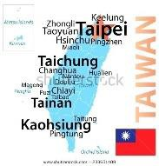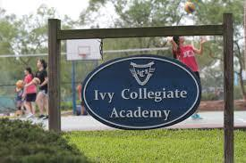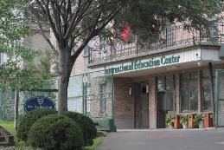

Dates: July 5, 2023 - August 5, 2023 – (orientation & 4 weeks teaching). Recognize due to COVID all aspects of the internship dates and activities remain tentative & will be confirmed by May 15, 2023. Documentation of full COVID vaccination is required by May 15, 2023.

Program Description:
- During this fun and interactive “Summer Study School” program ISU teaching interns will assist with the activities, classes, field trips, & residential life at Ivy Collegiate Academy working with students grades 5-12.
- Participants should like working with children inside and outside of the classroom, possess a willingness to be part of an interactive school culture, and contribute to an environment that respects multiple cultures.
- ISU teaching interns will be working with experienced teachers at Ivy Collegiate Academy’s “Summer Study School” program and residing in faculty & student housing.
- Ivy Collegiate Academy is a residential Middle School & High School located in Taichung, Taiwan.
- Participants will be paid $1,000 for the summer of work. Note: round-trip airfare, school-related field trips, accommodations, and food will be provided by the school.

Eligibility:
- Juniors, seniors, and graduate students in all majors. Cumulative GPA of 2.75 or higher.
- Preference will be given to teacher education students. Other students who have a strong interest in teaching will also be considered.
- Good academic and disciplinary standing.
- Participants are selected through a competitive application & interview process.
- Resume & Study Abroad Application required
- Documentation of Passport or submitted Passport application required by February 15, 2023.

Cost & Application Process:
- $300 study abroad application fee & $33.41 travel insurance (due once accepted & committed).
- Valid Passport & Personal spending money required (suggested amount at least $500-$700)
- Application Deadline: February 1, 2023 – Applicants will be notified by February 28, 2023 (competitive interviews).
- Application link. https://studyabroadapp.illinoisstate.edu/index.cfm?FuseAction=Programs.ViewProgramAngular&id=23166
- Required components: ISU study abroad application, electronic faculty recommendation, resume, and interviews.
- Once accepted there is a required online orientation for all ISU Study Abroad experiences.
- Students are required to register for a 2-credit study abroad course (pay for 1 credit) & Scholarships are available.

Additional Information:
- School Website: https://ica.ivyjhs.tc.edu.tw/
- Contact Dr. Monica Noraian, Acting Director, Cecilia J. Lauby Teacher Education Center, mcnora2@ilstu.edu for program-related questions or Carla Shanley, cmshanl@ilstu.edu for study abroad or application questions.
