Selected Results from a 50-State Policy Review of Policies for Principal Preparation Program Approval and Licensure

Policies for principal preparation and certification are important levers for improving school leadership. By developing a rubric of research-based practices, UCEA hopes to provide a formative tool for policymakers. Using a policy analysis frame by Roach et al. (2011), the excerpted results from his project explore the state code, administrative rules and regulations, and accompanying state board/department of education documents to describe state policies for principal preparation program approval and candidate licensure. There is variation in the extent to which states have adopted policies in these areas. Proportionately, more states have adopted policies for candidate licensure despite greater empirical evidence for preparation program approval (Hackmann, 2013).

This project seeks to explore the state-level policies included in statutes, rules and regulations, and associated documents from state boards and departments of education in order to answer the following research questions: 1) Which, if any, of the research-based components of a high-quality, principal preparation program are legislated in state statutes, rules and regulations, and state board and/or department of education policies?; 2) Which, if any, of the research-based standards for principal candidate licensure are legislated in state statutes, rules and regulations, and state board and/or department of education policies? The purpose of this study is not to produce an evaluative report but to create a formative self-assessment tool, which is grounded in research that will support the work of state policymakers.

In order to develop research-based rubrics to explore state policies, the project started with a review of the research literature. Despite finding a limited number of publications on principal preparation and licensure, only peer-reviewed journal articles were included. Book chapters, dissertations, conference papers and reports were not included. It is worth noting that due to the paucity of research in this area, however, these non-vetted sources are commonly found in the literature reviews of empirical pieces written about preparation. Through this process, a research-based rubric was developed and revised. The rubric was then pilot-tested using data collected from nine states (CA, FL, KY, MA, MS, ND, NY, OR, and VA). The pilot states were purposefully selected by the project planning committee to represent diverse policy contexts, ensure inter-rater reliability, and further revise the rubric.

The data collection for this project occurred between August 2013 and April 2014 at the University of Virginia Law Library. The primary sources used included published state codes and associated administrative codes/rules and regulations and documentation from state education agencies. This data was coded based on the elements of the rubric and data sources in order to evaluate the presence or absence of state policy aligned with the elements of the rubric.

This report highlights selected results from this project, including: Rubric Elements and Results for State Policy Requirements for Principal Preparation Program Approval (Table 1) and Candidate Licensure (Table 2); Proportion of Rubric Elements Included in State Policy by State (Figure 1), and a matrix of state-by-state policy elements (Table 3 and Table 4).

Table 1
Rubric Elements & Results: State Policy Requirements for Principal Preparation Program Approval
Criteria | Count (%)
Selection Processes
- Requires explicit plan for the selection process of incoming students
1.1. Includes a plan for targeted recruitment | 1 (1.9%)
1.2. Utilizes performance-based assessments | 5 (9.8%)
Program Standards
- Requires adoption of standards
2.1. Has adopted or adapted school leadership standards from a nationally recognized organization | 51 (100%)
Program Structures
- Requires clinically rich internship
3.1. Deliberately structured | 19 (37.2%)
- Field work is tightly integrated with curriculum | 15 (29.4%)
- Engagement in core leadership responsibilities | 19 (37.2%)
- Supervision by an expert veteran | 22 (43.1%)
- Exposure to multiple sites with diverse populations | 16 (31.3%)
- Requires 300+ hours of field-based experience | 15 (29.4%)
- Requires formal university-district partnership
- Commitment from district to provide a clinically rich internship experience | 10 (19.6%)
- District-provider collaboration on selection | 9 (17.6%)
- Alignment between district needs and program design | 11 (21.5%)
Program Oversight
- Requires rigorous program oversight
- Requires state review at specified intervals | 23 (45.0%)
- Plan for initial program oversight includes documentation and site visits | 28 (54.9%)
- Requires oversight team to have relevant experience and training | 27 (52.9%)
- Includes feedback mechanism to improve practice | 25 (49.0%)

Table 2
Rubric Elements & Results: State Policy Requirements for Principal Candidate Licensure
Criteria | Count (%)
Experience
- Teaching Experience
1.1. Requires 3+ years of teaching experience | 40 (78.4%)
- Master's Degree Requirements
2.1. Requires a master's degree in educational leadership or a closely related field | 26 (50.9%)
2.2. Master's degree earned from an accredited preparation program | 34 (66.6%)
2.3. Master's degree requires at least 30 credit hours | 8 (15.6%)
Licensure Pathways
- Alternative Pathway Requirements
3.1. Allows for alternative pathways for licensure | 29 (56.8%)
Assessment
- Score requirements
- Requires completion/passing of assessments | 30 (58.8%)
- Assessment content
- Assessments are closely based on national standards or aligned state standards | 26 (50.9%)
- Assessment includes (or is a) portfolio review | 5 (9.8%)
Renewal
- Licensure renewal
- Requires renewal with a distinction between provisional and professional licenses | 27 (52.9%)
- Licensure renewal requires meeting specified benchmarks | 29 (56.8%)
- Differentiation for renewal process based on license type | 23 (45.0%)

Proportion of Rubric Elements Included in State Policy by State

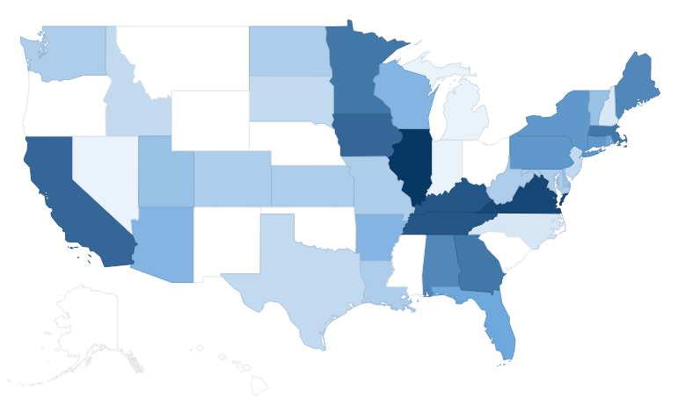

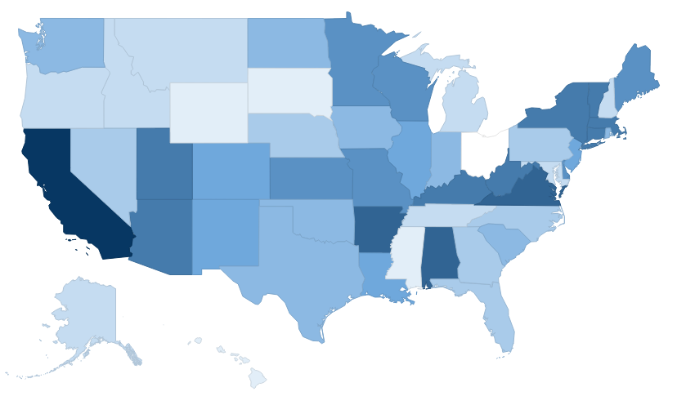

Figure 1. (Both) Darker shades correspond to higher proportions. (Top) Proportion of rubric requirements for principal preparation program (N=16) included by state. (Max. = 15 (e.g. IL); Min. = 1 (e.g. MT, OH). (Bottom) Proportion of rubric policy requirements for candidate licensure (N=11) included by state. (Max. = 11 (e.g. CA); Min. = 1 (e.g. OH).

Table 3
State-by-State Results: the Preparation Program Approval Rubric

State | Selection |  | Standards | Program Structures |  |  |  |  |  |  |  |  | Program Oversight
 | Plan |  | Standards | Clinically Rich Internship |  |  |  |  |  | Partnerships |  |  | Rigorous Oversight
 | 1.1 | 1.2 | 2.1 | 3.1 | 3.2 | 3.3 | 3.4 | 3.5 | 3.6 | 4.1 | 4.2 | 4.3 | 5.1 | 5.2 | 5.3 | 5.4
AL |  | X | X | X | X | X | X | X |  | X | X | X
AK |  |  | X
AZ |  |  | X | X | X | X | X |  |  |  |  |  |  | X | X
AR |  |  | X | X |  |  | X |  |  |  |  |  | X | X | X | X
CA |  |  | X | X | X | X | X | X |  | X | X | X |  | X | X | X
CO |  |  | X | X |  |  | X |  | X |  |  |  |  | X
CT |  |  | X | X | X | X |  | X |  |  |  |  | X | X | X | X
DE |  |  | X |  |  | X | X |  | X |  |  |  | X |  |  | X
DC |  |  | X |  |  |  |  |  |  |  |  |  |  | X | X
FL |  |  | X |  |  | X | X |  |  | X |  | X | X | X |  | X
GA |  |  | X | X | X | X | X | X |  |  |  | X | X | X | X | X
HI |  |  | X
ID |  |  | X |  |  |  |  |  |  |  |  |  | X | X | X
IL |  | X | X | X | X | X | X | X | X | X | X | X | X | X | X | X
IN |  |  | X |  |  |  |  |  |  |  |  |  |  |  |  | X
IA |  | X | X | X | X | X | X | X | X |  |  |  | X | X | X | X
KS |  |  | X |  |  |  |  |  |  |  |  |  | X | X | X | X
KY |  |  | X | X | X | X | X | X |  | X | X | X | X | X | X | X
LA |  |  | X |  |  |  |  |  |  |  |  |  | X | X | X | X
ME |  |  | X | X | X | X | X |  | X |  |  |  | X | X | X | X
MD |  |  | X |  |  |  |  |  |  |  |  |  | X | X | X | X
MA |  |  | X | X | X | X | X | X | X |  | X | X |  | X | X
MI |  |  | X |  |  |  |  |  |  |  |  |  | X
MN |  |  | X | X | X | X | X | X | X |  |  |  | X | X | X | X
MS |  |  | X
MO |  |  | X | X | X | X |  |  | X
MT |  |  | X
NE |  |  | X
NV |  |  | X |  |  |  |  |  |  |  |  |  | X
NH |  |  | X |  |  |  |  |  |  |  |  |  |  | X |  | X
NJ |  |  | X |  |  | X |  |  | X |  |  |  |  |  | X
NM |  |  | X
NY |  |  | X | X | X |  | X | X | X | X |  | X |  |  | X
NC |  |  | X |  |  |  |  |  |  | X | X
ND |  |  | X |  |  |  |  |  |  |  |  |  | X | X | X | X
OH |  |  | X
OK |  |  | X
OR |  |  | X
PA |  | X | X | X |  |  | X |  | X | X | X | X |  | X
RI |  |  | X |  |  |  | X | X | X |  |  |  | X | X | X | X
SC |  |  | X
SD |  |  | X |  |  |  |  | X |  |  |  |  |  | X | X
TN | X | X | X |  | X | X | X | X |  | X | X | X |  | X | X | X
TX |  |  | X | X |  |  |  |  |  |  |  |  | X |  |  | X
UT |  |  | X | X |  | X | X | X | X
VT |  |  | X |  |  |  | X | X | X |  |  |  |  |  | X | X
VA |  |  | X | X | X | X | X | X | X | X | X | X | X | X | X | X
WA |  |  | X |  |  |  |  |  |  |  |  |  | X | X | X | X
WV |  |  | X |  |  |  |  |  |  |  |  |  | X | X | X | X
WI |  |  | X |  |  | X | X |  |  |  |  |  | X | X | X | X
WY |  |  | X
Total | 1 | 5 | 51 | 19 | 15 | 19 | 22 | 16 | 15 | 10 | 9 | 11 | 23 | 28 | 27 | 25

Table 4
State-by-State Results for the Candidate Licensure Rubric

State | Experience |  |  |  | Licensure | Assessment |  |  | Renewal
 | Teaching | Master’s Degree |  |  | Alt. Path. | Score | Content |  | Licensure Renewal
 | 1.1 | 2.1 | 2.2 | 2.3 | 3.1 | 4.1 | 5.1 | 5.2 | 6.1 | 6.2 | 6.3
AL | X |  | X | X | X | X | X |  | X | X | X
AK | X |  | X |  |  |  |  |  | X
AZ | X |  | X | X | X | X | X |  | X | X
AR | X | X | X |  | X | X | X |  | X | X | X
CA | X | X | X | X | X | X | X | X | X | X | X
CO | X |  | X |  | X |  |  |  | X | X | X
CT | X | X | X |  | X | X | X |  | X | X
DE | X | X | X |  | X |  |  |  | X | X | X
DC |  | X | X |  | X | X | X |  |  | X
FL |  | X | X |  |  | X | X
GA |  |  | X |  | X | X |  |  | X
HI | X |  |  |  | X
ID | X |  | X | X
IL | X |  | X |  | X | X | X |  |  | X
IN |  |  | X |  |  | X | X |  | X | X
IA | X |  | X |  |  |  |  |  | X | X | X
KS | X |  | X |  |  | X | X |  | X | X | X
KY | X |  | X |  | X | X | X |  | X | X | X
LA |  |  | X |  | X | X | X |  | X | X
ME | X |  |  |  | X | X | X |  | X | X | X
MD | X |  |  |  |  | X | X
MA | X |  | X |  |  | X | X | X | X | X | X
MI |  |  | X |  | X |  |  |  |  | X
MN | X |  | X | X |  |  |  | X | X | X | X
MS |  |  |  |  | X | X
MO |  | X | X |  |  | X | X |  | X | X | X
MT | X | X |  |  |  |  |  |  |  | X
NE | X | X |  |  |  |  |  |  | X |  | X
NV | X | X | X | X
NH | X | X |  |  | X
NJ | X | X | X | X |  | X | X
NM | X | X | X |  | X | X | X
NY | X |  | X |  | X | X | X |  | X | X | X
NC | X | X | X |  |  | X
ND | X | X | X |  |  |  |  |  |  | X | X
OH |  |  |  |  | X
OK | X | X |  |  | X | X | X
OR | X |  | X |  |  |  |  |  |  |  | X
PA | X | X |  |  |  | X |  | X
RI | X | X |  |  | X | X | X
SC | X | X |  |  | X | X | X
SD | X |  |  |  |  |  |  |  | X
TN |  |  |  |  |  |  |  |  | X | X | X
TX | X | X | X |  |  | X | X
UT | X | X |  |  | X | X | X |  | X | X | X
VT | X |  |  |  | X | X | X | X | X | X | X
VA | X | X | X |  | X | X | X |  | X | X | X
WA | X | X |  |  | X |  |  |  |  | X | X
WV | X | X | X | X | X |  |  |  | X | X | X
WI | X | X | X |  | X |  |  |  | X | X | X
WY |  | X | X
Total | 40 | 26 | 34 | 8 | 29 | 30 | 26 | 5 | 27 | 29 | 23

