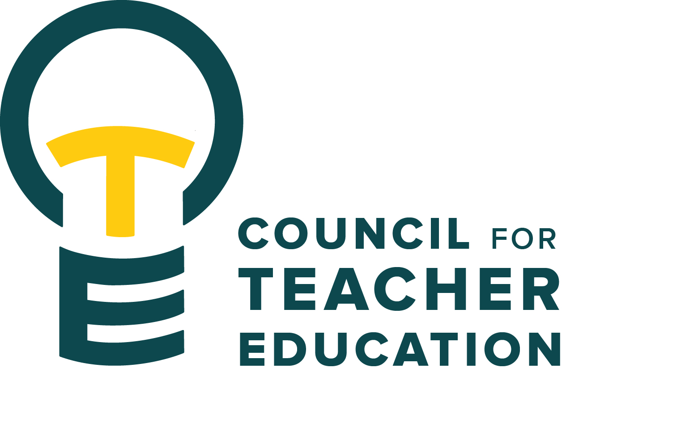

Council for Teacher Education
Meeting Minutes
February 7, 2023, 3:00-4:30 pm
Members Present: Christie Angleton, Nesrin Bakir, Alan Bates, Christy Bazan, Sarah Boesdorfer, Jimmy Chrismon, Yojanna Cuenca-Carlino, Francis Godwyll, Phil Hash, Amy Hurd, Stacey Jones-Bock, Jeongae Kang, Allison Kroesch, Miranda Lin, Cassandra Mattoon, Gary Cates for Adena Meyers, Kathy Mountjoy, Monica Noraian, Jay Percell, Dianne Renn, Rocio Rivadeneyra, Noelle Selkow, Caitlin Stewart, Jill Thomas, Matthew Winsor

Absent: Judy Bee, Mary Henninger, Aamari Taylor, Darby Wilde, Diane Zosky

Guests: Jill Donnel, Troy Hinkel, Barb Jacobsen, Laurie Sexton

- Call to order: Monica Noraian called the meeting to order at 3:00 pm
- Roll Call: Christy Bazan conducted a roll call.
- Approval of minutes from January 17, 2023, meeting: Jay Percell motioned to approve the minutes with Jill Thomas as the second to the motion. All those present were in favor aside from one abstention. The minutes were approved.
- Information Items
  - ISBE update: Illinois Professional Educator Standards - On December 29, 2022, the new Illinois Professional Educator Standards (IPES) were finalized and posted within the Illinois Administrative Code. These standards will replace the 2013 Illinois Professional Teaching Standards (IPTS) and can be found in Section 24.140: https://www.isbe.net/Documents/24ark.pdf. Effective July 1, 2024, all teacher preparation programs seeking approval must be aligned to these standards. Effective June 30, 2026, previously approved programs must be realigned to these standards. To assist institutions with the transition process, ISBE will soon release a guide that will include the transition timeline, process, and expectations. Please watch for additional information coming soon.
  - General Disposition Concerns Overview: updates & information provided by Troy Hinkel. 3-year average data was provided to the council.
  - Increasing CTE & Teacher Education Communication: Sharing Ideas and News of What is Happening Around Campus
        - Lauby Teacher Education Center | College of Education - Illinois State (CTE minutes, members, committees)
        - Teacher Education Gateway & Milestone Check List/Guide (TEC) (T. Hinkel) Looking for ways to encourage timely completion of PBA training and reinforce the information provided. A checklist is being formulated.
        - Advisor Teacher Education Guide (TEC) (T. Hinkel) Staff should reach out to Troy if they are interested in a copy.
        - AAC-ED (J. Thomas) February 22, 2023, Chat with Troy and UCollege Advisors and Department Advisors; Registration will remain open without a pause period as has been the case previously. Contact Jill Thomas for further information.
        - RSO – Teacher Education Student Life | College of Education - Illinois State
- Subcommittees
  - Curriculum: Noelle Selkow – Approved changes (synopsis provided by Curriculum Committee)
- English Teaching Ed: revision to increase ENG hours and decrease hours in professional education
    - Adding ENG 399 to be concurrent with 399a09 and removing ENG 324
- ENG 399: new course to provide a professional learning community while in student teaching. Align methods coursework with field experience.
- KNR 444: new course satisfies Standard 2 by understanding how individuals grow, develop, and learn in the physical domain. Part of MAT in TCH
- TCH 216.02: new course as the lab for theatre experience at UHigh
- SED 364: revised course to remove graduate-level components
- ART 307: adding IDEAS graduation requirements
- MUS 264: adding instruction in digital audio workstation for elementary and secondary music
Approved pending changes
- TCH 226: new course providing competencies in research-informed, developmentally appropriate, culturally responsive social studies and science. Pathway for endorsement in ECE and content for non-ECE majors
- TCH 228: new course, same as TCH 226 but with MLE focus.
  - Student Interests: Jay Percell –The committee will reach out to the EFAW Center and Dakesa Pina on Student Concerns Listening Circles. They are beginning to plan for the Student Excellence Award and welcome suggestions for this year’s theme.
  - University Liaison and Faculty Interests: Yojanna Cuenca-Carlino – The committee met to welcome new members. They are getting acquainted with their CAEP assignment.
  - University Teacher Education Assessment: Christy Bazan – Work is wrapping up on AARs. They are cleaning up the Lesson Plan Key Assessment documents to clarify directions.
  - Vision: Jill Thomas – Wendy Smith & Gary Higham met with the committee to see how to move on with disposition concerns. They reviewed CPAST & pre-CPAST to see how they fit in.
- Discussion Items:
  - ISBE has contracted with an outside group for CRTLS – Efforts will be paused until more information is provided.
- Action Items: none
- Legislative Updates: none
- Announcements and Last Comments:
  - Metcalf Lab School will be hosting a colloquium on Friday, February 10th with the goal of building relationships to enhance the pre-service teacher education and research experience.
  - Normal Parks & Recreation will host a job fair on Wednesday, March 1st from 5-7 p.m. These summer positions might appeal to teacher education students.
  - Work continues regarding the transition plan to Canvas learning management system. They are looking at the data collection aspect and reaching out to Kansas State about their experience.
  - TCH and SED have developed new programs with state and donor support – there is strong interest
- Adjournment: 4:20 pm

Next CTE Executive Board Meeting: February 14, 2023, 2:00-3:00 pm DEG 506A (alternative room DEG 52)
Next CTE Subcommittee Meetings: February 14, 2023
Curriculum: co-chairs, Noelle Selkow & Mary Henninger (DEG 304) 3:30-4:30 pm
University Liaison and Faculty Interests: Chair, Yojanna Cuenca-Carlino (DEG 504) 3:00-4:30 pm
University Teacher Education Assessment Committee: Co-Chairs, Christy Bazan & Monica Noraian (DEG 551) 3:00-4:30 pm
Vision: Chair, Jill Thomas (DEG 506A) 3:00-4:30 pm (alternative room DEG 52)
Student Interests: Chair, Jay Percell (STV 140) 3:30-4:30 pm
Next CTE meeting: February 21, 2023 (DEG 551) 3:00-4:30 pm
CTE (1st and 3rd Tuesdays) DEG 551 | Exec & Subcommittees (2nd and 4th Tuesdays)
Feb. 7 | Feb. 14
Feb. 21 | Feb. 28
March 7 | Spring Break
March 21 | March 28
April 4 | April 11
April 18 | April 25
May 2 | May 9

