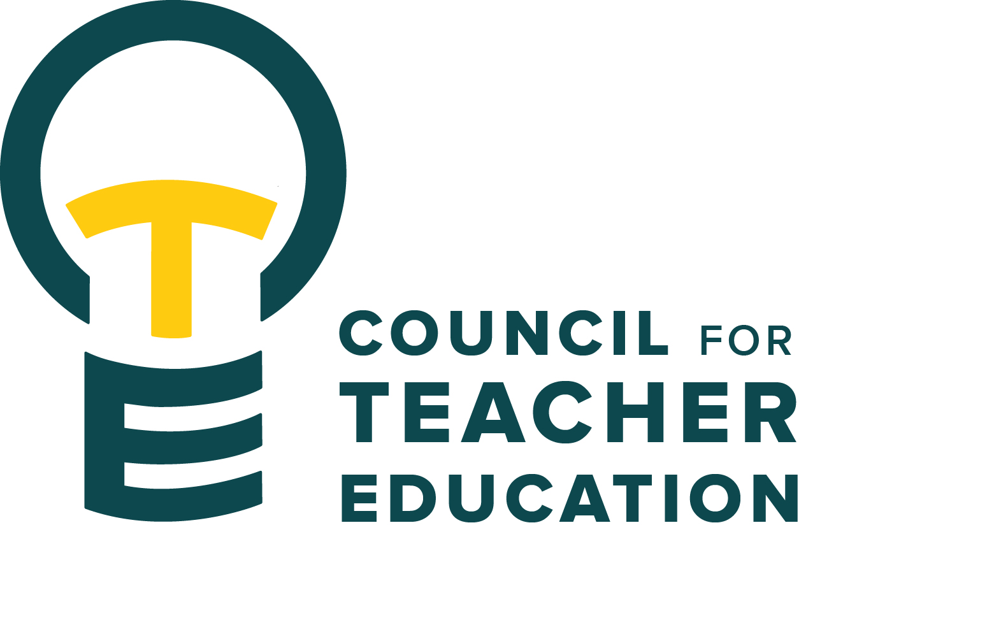

Council for Teacher Education
Meeting Agenda
February 21, 2023, 3:00-4:30 pm, DeGarmo 551
- Call to order
- Roll Call (In Attendance & Absent)
- Approval of minutes from the February 7th meeting
- Information Items:
- Updates from the Dean (Francis Godwyll)
V. Subcommittee Reports:
- Curriculum (& CAEP standard 2 working group) (Noelle Selkow & Mary Henninger)
- Student Interests (& CAEP standard 3 working group) (Jay Percell)
- University Liaison and Faculty Interest (& CAEP standard 5 working group) (Yojanna Cuenca-Carlino)
- University Teacher Education Assessment (& CAEP standard 1 working group) (Christy Bazan & Monica Noraian)
- Vision (& CAEP standard 4 working group) (Jill Thomas)
VI.Discussion Items:
- CAEP: Updates & CAEP Committee Workday Check-in/Report out & Next steps (Laurie Sexton)
VII. Action Items:
VIII. Legislative Updates:
IX. Announcements and Last Comments:
- The Hunter Family Trust Scholarship – Student Opportunity
- D87 Summer School Teacher Intern Opportunity
- Midwest ATE spring conference
- Manuscript request for CITE
X. Adjournment:
Next CTE Executive Board Meeting: February 28, 2023, 2-3 pm Next CTE Subcommittee Meetings: February 28, 2023, 3:00-4:30 pm
Curriculum (& CAEP standard 2 working group): Co-Chairs Noelle Selkow & Mary Henninger (DEG 304 3:30-4:30)
Student Interests Committee (& CAEP standard 3 working group): Chair Jay Percell (STV 140 3:30-4:30)
University Liaison and Faculty Interests (& CAEP standard 5 working group): Chair Yojanna Cuenca-Carlino (DEG 504 3-4:30)
University Teacher Education Assessment Committee (& CAEP standard 1 working group): Co-Chairs Bazan & Noraian (DEG 551 3:00-4:00)
Vision (& CAEP standard 4 working group): Chair Jill Thomas (DEG 506A 3:00-4:30)
Next CTE Meeting: March 7, 2023, 3:00-4:30 pm DeGarmo 551 2022-2023 CTE & COMMITTEE MEETING SCHEDULE
CTE (1st and 3rd Tuesdays) DEG 551 | Exec & Subcommittees (2nd and 4th Tuesdays)
Feb. 21 | Feb. 28
March 7 | Spring Break
March 21 | March 28
April 4 | April 11
April 18 | April 25
May 2 | May 9

